composer.json and composer.lock

📄 What Are composer.json and composer.lock in PHP?
# Source: AI Source: Provided by: [Data Path: Persons Table -> ID Column: 1, Name_En Column: Motasem Essam] -> From: [Chatgpt (GPT‑5 Mini)] on [1/26/2026]
These two files work together in Composer, PHP’s dependency manager, to manage your project’s libraries (packages) and ensure consistency across environments.

🔧 composer.json
# Source: AI Source: Provided by: [Data Path: Persons Table -> ID Column: 1, Name_En Column: Motasem Essam] -> From: [Chatgpt (GPT‑5 Mini)] on [1/26/2026]
This is the main configuration file you write or edit.
✅ Purpose:
- Lists the packages your project needs
- Defines autoloading rules
- Includes project metadata (name, author, license, etc.)

🧩 Example:
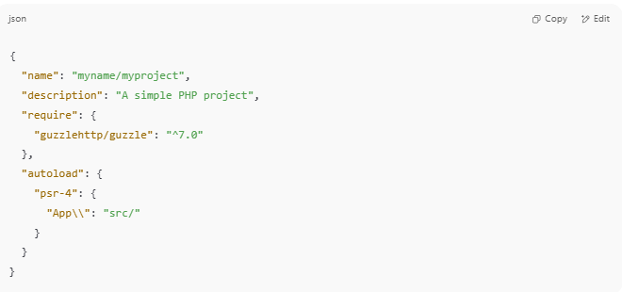
{
"name": "myname/myproject",
"description": "A simple PHP project",
"require": {
"guzzlehttp/guzzle": "^7.0"
},
"autoload": {
"psr-4": {
"App\\": "src/"
}
}
}

✏️ You edit this manually or via:
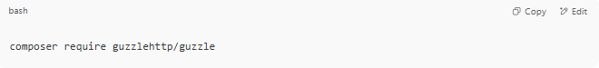
composer require guzzlehttp/guzzle

🛠 Key Sections Explained
# Source: AI Source: Provided by: [Data Path: Persons Table -> ID Column: 1, Name_En Column: Motasem Essam] -> From: [Chatgpt (GPT‑5 Mini)] on [1/26/2026]
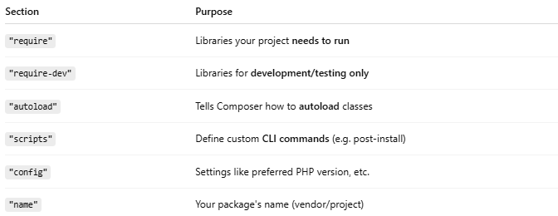

Section | Purpose
"require" | Libraries your project needs to run
"require-dev" | Libraries for development/testing only
"autoload" | Tells Composer how to autoload classes
"scripts" | Define custom CLI commands (e.g. post-install)
"config" | Settings like preferred PHP version, etc.
"name" | Your package's name (vendor/project)

📦 What Are the Uses of name and description in composer.json?
# Source: AI Source: Provided by: [Data Path: Persons Table -> ID Column: 1, Name_En Column: Motasem Essam] -> From: [Chatgpt (GPT‑5 Mini)] on [1/26/2026]
Great question! Let's break it down clearly:

🏷️ "name": Project Identifier
# Source: AI Source: Provided by: [Data Path: Persons Table -> ID Column: 1, Name_En Column: Motasem Essam] -> From: [Chatgpt (GPT‑5 Mini)] on [1/26/2026]
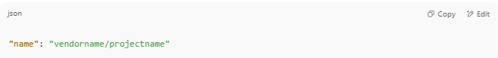
"name": "vendorname/projectname"

✅ Purpose:
- Uniquely identifies your package
- Required if you plan to publish it (on Packagist.org)
- Used for composer require or as a dependency name in other projects
🔍 Example:
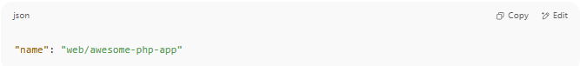
"name": "web/awesome-php-app"

📌 If another project wants to use your package, they'd write:
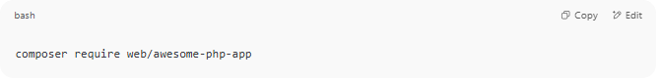
composer require web/awesome-php-app

📝 "description": Human-readable Info
# Source: AI Source: Provided by: [Data Path: Persons Table -> ID Column: 1, Name_En Column: Motasem Essam] -> From: [Chatgpt (GPT‑5 Mini)] on [1/26/2026]
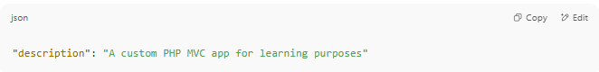
"description": "A custom PHP MVC app for learning purposes"

✅ Purpose:
- Provides a summary of what your project does
- Appears in:
  - composer show
  - Packagist.org listings
  - GitHub or IDE tools that parse composer.json
- Helps developers quickly understand your project

👤 What Is the Use of "authors" in composer.json?
# Source: AI Source: Provided by: [Data Path: Persons Table -> ID Column: 1, Name_En Column: Motasem Essam] -> From: [Chatgpt (GPT‑5 Mini)] on [1/26/2026]
The "authors" section in composer.json is used to document the people or teams who created or maintain the project. It’s optional but highly recommended, especially for open-source or team projects.
📄 Format of "authors"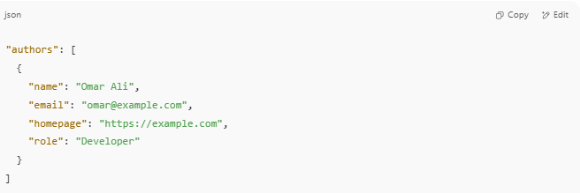
"authors": [
{
"name": "Omar Ali",
"email": "omar@example.com",
"homepage": "https://example.com",
"role": "Developer"
}
]

Only "name" is required — the rest are optional.

✅ Why Use "authors"?
# Source: AI Source: Provided by: [Data Path: Persons Table -> ID Column: 1, Name_En Column: Motasem Essam] -> From: [Chatgpt (GPT‑5 Mini)] on [1/26/2026]
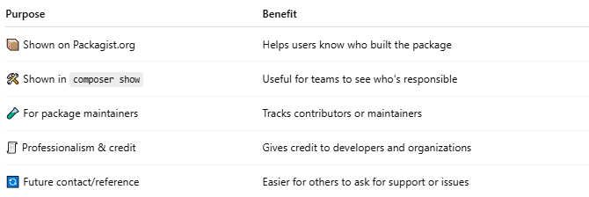

Purpose | Benefit
📦 Shown on Packagist.org | Helps users know who built the package
🛠 Shown in composer show | Useful for teams to see who's responsible
🧪 For package maintainers | Tracks contributors or maintainers
🧾 Professionalism & credit | Gives credit to developers and organizations
🔄 Future contact/reference | Easier for others to ask for support or issues

🧰 Where It's Used
# Source: AI Source: Provided by: [Data Path: Persons Table -> ID Column: 1, Name_En Column: Motasem Essam] -> From: [Chatgpt (GPT‑5 Mini)] on [1/26/2026]
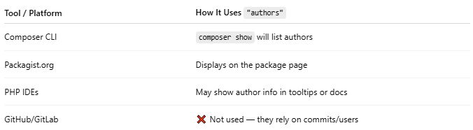

Tool / Platform | How It Uses "authors"
Composer CLI | composer show will list authors
Packagist.org | Displays on the package page
PHP IDEs | May show author info in tooltips or docs
GitHub/GitLab | ❌ Not used — they rely on commits/users

🧠 Example with Multiple Authors
# Source: AI Source: Provided by: [Data Path: Persons Table -> ID Column: 1, Name_En Column: Motasem Essam] -> From: [Chatgpt (GPT‑5 Mini)] on [1/26/2026]
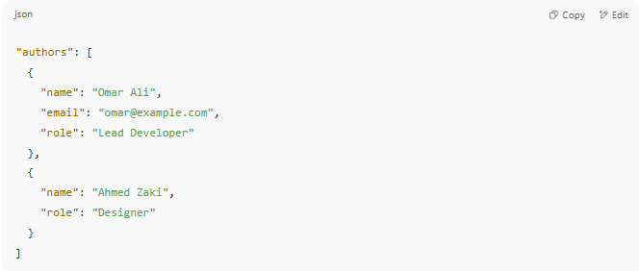
"authors": [
{
"name": "Omar Ali",
"email": "omar@example.com",
"role": "Lead Developer"
},
{
"name": "Ahmed Zaki",
"role": "Designer"
}
]

✅ Summary
# Source: AI Source: Provided by: [Data Path: Persons Table -> ID Column: 1, Name_En Column: Motasem Essam] -> From: [Chatgpt (GPT‑5 Mini)] on [1/26/2026]
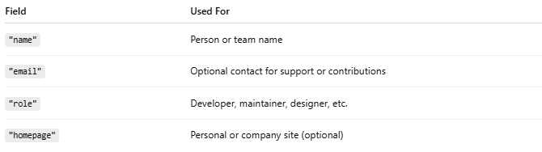

Field | Used For
"name" | Person or team name
"email" | Optional contact for support or contributions
"role" | Developer, maintainer, designer, etc.
"homepage" | Personal or company site (optional)

❓ Does Git Use composer.json Fields Like "name" or "description"?
# Source: AI Source: Provided by: [Data Path: Persons Table -> ID Column: 1, Name_En Column: Motasem Essam] -> From: [Chatgpt (GPT‑5 Mini)] on [1/26/2026]
🔴 No — Git does not use composer.json's name or description fields at all.
Git is only concerned with:
- Tracking file changes (like composer.json itself)
- Managing branches, commits, and versions
- Handling repository hosting (GitHub, GitLab, etc.)

✅ Who Uses composer.json Fields?
# Source: AI Source: Provided by: [Data Path: Persons Table -> ID Column: 1, Name_En Column: Motasem Essam] -> From: [Chatgpt (GPT‑5 Mini)] on [1/26/2026]
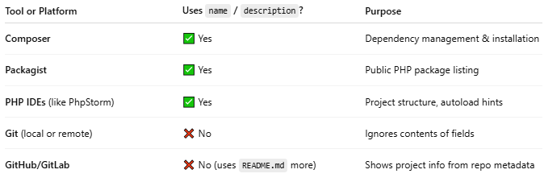

Tool or Platform | Uses name / description? | Purpose
Composer | ✅ Yes | Dependency management & installation
Packagist | ✅ Yes | Public PHP package listing
PHP IDEs (like PhpStorm) | ✅ Yes | Project structure, autoload hints
Git (local or remote) | ❌ No | Ignores contents of fields
GitHub/GitLab | ❌ No (uses README.md more) | Shows project info from repo metadata

🧠 What Git Does Track About Composer
# Source: AI Source: Provided by: [Data Path: Persons Table -> ID Column: 1, Name_En Column: Motasem Essam] -> From: [Chatgpt (GPT‑5 Mini)] on [1/26/2026]
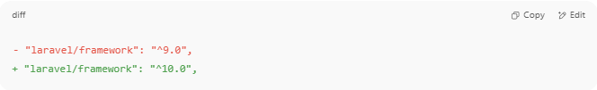
- "laravel/framework": "^9.0",
+ "laravel/framework": "^10.0",

📝 Related Git Best Practices
# Source: AI Source: Provided by: [Data Path: Persons Table -> ID Column: 1, Name_En Column: Motasem Essam] -> From: [Chatgpt (GPT‑5 Mini)] on [1/26/2026]

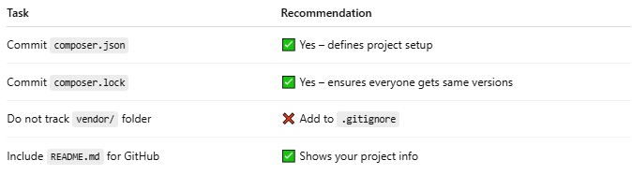

Task | Recommendation
Commit composer.json | ✅ Yes – defines project setup
Commit composer.lock | ✅ Yes – ensures everyone gets same versions
Do not track vendor/ folder | ❌ Add to .gitignore
Include README.md for GitHub | ✅ Shows your project info

✅ Summary
# Source: AI Source: Provided by: [Data Path: Persons Table -> ID Column: 1, Name_En Column: Motasem Essam] -> From: [Chatgpt (GPT‑5 Mini)] on [1/26/2026]
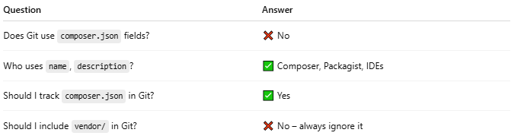

Question | Answer
Does Git use composer.json fields? | ❌ No
Who uses name, description? | ✅ Composer, Packagist, IDEs
Should I track composer.json in Git? | ✅ Yes
Should I include vendor/ in Git? | ❌ No – always ignore it

📌 Summary of Differences
# Source: AI Source: Provided by: [Data Path: Persons Table -> ID Column: 1, Name_En Column: Motasem Essam] -> From: [Chatgpt (GPT‑5 Mini)] on [1/26/2026]
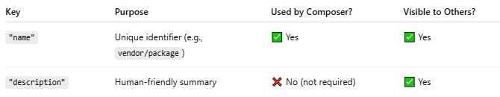
Key | Purpose | Used by Composer? | Visible to Others?
"name" | Unique identifier (e.g., vendor/package) | ✅ Yes | ✅ Yes
"description" | Human-friendly summary | ❌ No (not required) | ✅ Yes

🧠 Real-World Use Cases
# Source: AI Source: Provided by: [Data Path: Persons Table -> ID Column: 1, Name_En Column: Motasem Essam] -> From: [Chatgpt (GPT‑5 Mini)] on [1/26/2026]
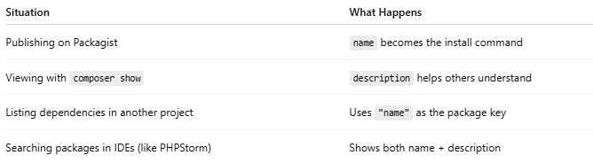

Situation | What Happens
Publishing on Packagist | name becomes the install command
Viewing with composer show | description helps others understand
Listing dependencies in another project | Uses "name" as the package key
Searching packages in IDEs (like PHPStorm) | Shows both name + description

✅ Best Practice Example
# Source: AI Source: Provided by: [Data Path: Persons Table -> ID Column: 1, Name_En Column: Motasem Essam] -> From: [Chatgpt (GPT‑5 Mini)] on [1/26/2026]
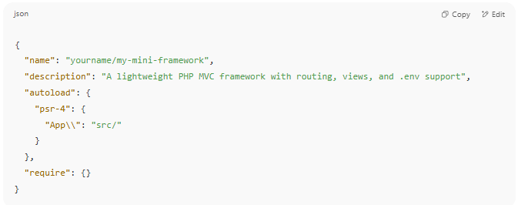

{
"name": "yourname/my-mini-framework",
"description": "A lightweight PHP MVC framework with routing, views, and .env support",
"autoload": {
"psr-4": {
"App\\": "src/"
}
},
"require": {}
}

⚙️ How to Define Custom CLI Commands in Composer (composer.json)
# Source: AI Source: Provided by: [Data Path: Persons Table -> ID Column: 1, Name_En Column: Motasem Essam] -> From: [Chatgpt (GPT‑5 Mini)] on [1/26/2026]
Composer lets you define custom commands using the scripts section in your composer.json. These are usually shell commands or PHP scripts that run when you type:
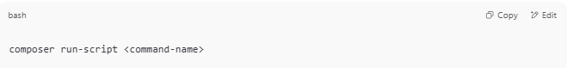
composer run-script <command-name>

🧩 Example: Define Custom CLI Commands

📄 composer.json
# Source: AI Source: Provided by: [Data Path: Persons Table -> ID Column: 1, Name_En Column: Motasem Essam] -> From: [Chatgpt (GPT‑5 Mini)] on [1/26/2026]
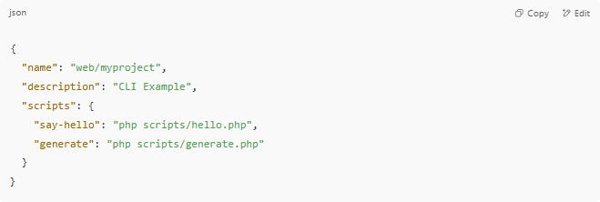
{
"name": "web/myproject",
"description": "CLI Example",
"scripts": {
"say-hello": "php scripts/hello.php",
"generate": "php scripts/generate.php"
}
}

📁 Folder structure
# Source: AI Source: Provided by: [Data Path: Persons Table -> ID Column: 1, Name_En Column: Motasem Essam] -> From: [Chatgpt (GPT‑5 Mini)] on [1/26/2026]
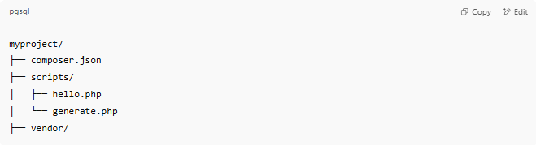
myproject/
├── composer.json
├── scripts/
│ ├── hello.php
│ └── generate.php
├── vendor/

📄 scripts/hello.php
# Source: AI Source: Provided by: [Data Path: Persons Table -> ID Column: 1, Name_En Column: Motasem Essam] -> From: [Chatgpt (GPT‑5 Mini)] on [1/26/2026]
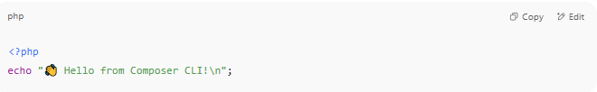
<?php
echo "👋 Hello from Composer CLI!\n";

📄 scripts/generate.php
# Source: AI Source: Provided by: [Data Path: Persons Table -> ID Column: 1, Name_En Column: Motasem Essam] -> From: [Chatgpt (GPT‑5 Mini)] on [1/26/2026]
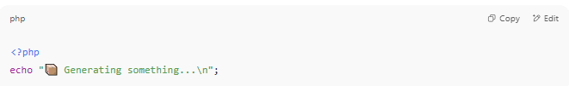
<?php
echo "📦 Generating something...\n";

▶️ Run Your Custom Commands
# Source: AI Source: Provided by: [Data Path: Persons Table -> ID Column: 1, Name_En Column: Motasem Essam] -> From: [Chatgpt (GPT‑5 Mini)] on [1/26/2026]
Use:
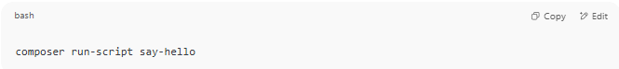
composer run-script say-hello

Or shorter:
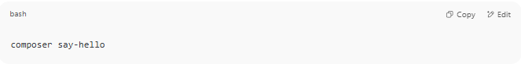
composer say-hello

Output:
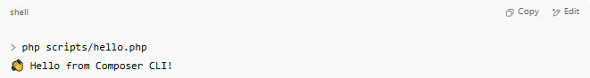
> php scripts/hello.php
👋 Hello from Composer CLI!

🔄 Useful Built-in Composer Events
# Source: AI Source: Provided by: [Data Path: Persons Table -> ID Column: 1, Name_En Column: Motasem Essam] -> From: [Chatgpt (GPT‑5 Mini)] on [1/26/2026]
Besides custom names, you can hook into built-in Composer events like:
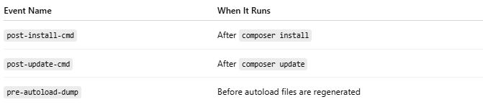
Event Name | When It Runs
post-install-cmd | After composer install
post-update-cmd | After composer update
pre-autoload-dump | Before autoload files are regenerated
Example:
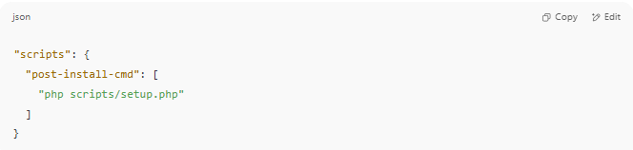
"scripts": {
"post-install-cmd": [
"php scripts/setup.php"
]
}

✅ Summary
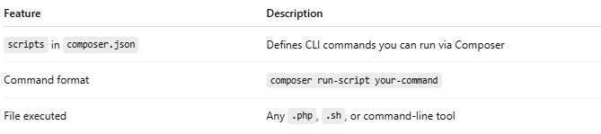

Feature | Description
scripts in composer.json | Defines CLI commands you can run via Composer
Command format | composer run-script your-command
File executed | Any .php, .sh, or command-line tool

📦 composer.lock
# Source: AI Source: Provided by: [Data Path: Persons Table -> ID Column: 1, Name_En Column: Motasem Essam] -> From: [Chatgpt (GPT‑5 Mini)] on [1/26/2026]
This file is auto-generated by Composer.
✅ Purpose:
- Records the exact versions of all installed packages
- Ensures every developer gets identical versions
- Improves reproducibility and stability
🧩 Example Content (simplified):
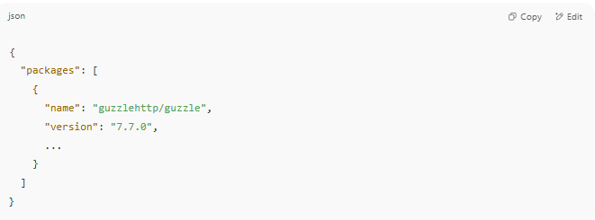
{
"packages": [
{
"name": "guzzlehttp/guzzle",
"version": "7.7.0",
...
}
]
}

⚠️ Do Not Edit It Manually!
Composer updates this file automatically when you run:
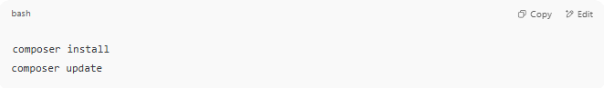
composer install
composer update

🎯 When They Work Together
# Source: AI Source: Provided by: [Data Path: Persons Table -> ID Column: 1, Name_En Column: Motasem Essam] -> From: [Chatgpt (GPT‑5 Mini)] on [1/26/2026]
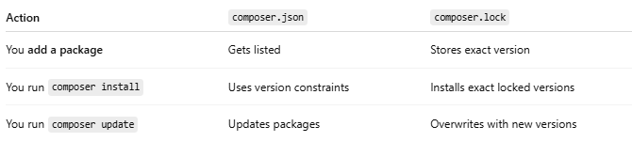

Action | composer.json | composer.lock
You add a package | Gets listed | Stores exact version
You run composer install | Uses version constraints | Installs exact locked versions
You run composer update | Updates packages | Overwrites with new versions

👥 Why Both Are Important
# Source: AI Source: Provided by: [Data Path: Persons Table -> ID Column: 1, Name_En Column: Motasem Essam] -> From: [Chatgpt (GPT‑5 Mini)] on [1/26/2026]
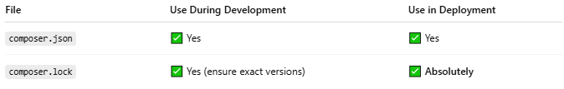

File | Use During Development | Use in Deployment
composer.json | ✅ Yes | ✅ Yes
composer.lock | ✅ Yes (ensure exact versions) | ✅ Absolutely

🔄 Used With Composer Commands
# Source: AI Source: Provided by: [Data Path: Persons Table -> ID Column: 1, Name_En Column: Motasem Essam] -> From: [Chatgpt (GPT‑5 Mini)] on [1/26/2026]
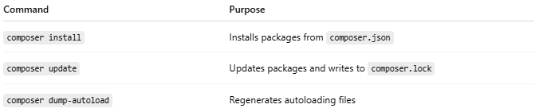

Command | Purpose
composer install | Installs packages from composer.json
composer update | Updates packages and writes to composer.lock
composer dump-autoload | Regenerates autoloading files

📁 Common Files Generated
# Source: AI Source: Provided by: [Data Path: Persons Table -> ID Column: 1, Name_En Column: Motasem Essam] -> From: [Chatgpt (GPT‑5 Mini)] on [1/26/2026]
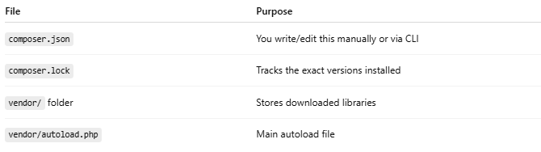

File | Purpose
composer.json | You write/edit this manually or via CLI
composer.lock | Tracks the exact versions installed
vendor/ folder | Stores downloaded libraries
vendor/autoload.php | Main autoload file

✅ Summary
# Source: AI Source: Provided by: [Data Path: Persons Table -> ID Column: 1, Name_En Column: Motasem Essam] -> From: [Chatgpt (GPT‑5 Mini)] on [1/26/2026]
💡 Summary
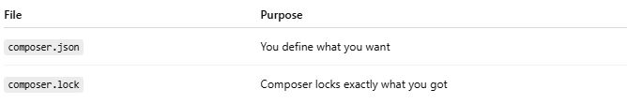

File | Purpose
composer.json | You define what you want
composer.lock | Composer locks exactly what you got
🛡️ Always commit both files to version control (like Git).

